**Experiment – 9**

**VIEWS**

**Aim:**

* Create table students with attributes id, name and department.
* Display
* Create view and select
* Insert values
* Create view with check option
* Insert values and alter table

**CODE WITH SOLUTIONS**

* Create table students with attributes id, name and department.
* Display

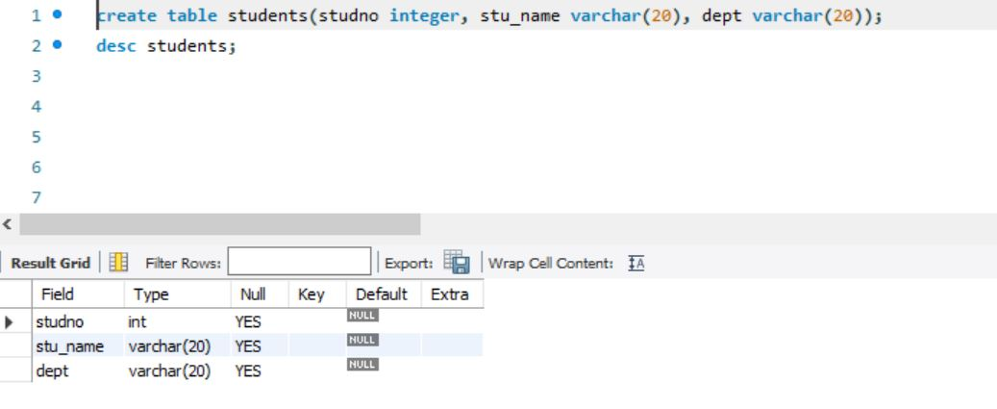

* Create view and select
* Insert values

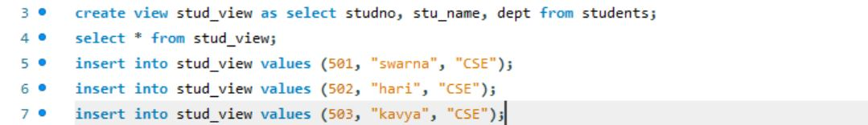

* Create view with check option
* Insert values and alter table

